Michigan Trauma Coalition Clinic Practice Guideline Disclaimer Statement
The Michigan Trauma Coalition (MTC) is a non-profit, membership organization comprised of trauma centers, health care professionals and organizations dedicated to reducing traumatic injuries while developing better care and treatment for trauma patients in Michigan. The guidelines presented on MTC's website are for informational purposes only and are not meant as advice of any kind. Please consult your legal counsel before implementing any trauma guidelines. The guidelines presented on MTC's website are examples only and are not intended to replace clinical judgment.
MTC makes no representations or warranty, express or implied, about the guidelines or any other items used either directly or indirectly from MTC’s website, and reserves the right to makes changes and corrections at any time, without notice. MTC accepts no liability for any inaccuracies or omission in the guidelines or in MTC’s website. Any decisions you make based on information contained in the guidelines or MTC’s website are solely your responsibility. MTC accepts no liability for any direct, indirect, special, consequential or other losses or damages of whatsoever kind arising out of access to, or the use of the guidelines or MTC’s website. MTC does not assume any legal liability or responsibility for the accuracy, completeness, clinical efficacy, and effectiveness of the guidelines hosted on MTC’s website. The hosting of these guidelines should not be considered an endorsement of its content, product, or apparatus or refutation of any alternate management strategy.
By using MTC's website, you agree that the exclusions and limitations of liability are reasonable. If you do not agree, you must not use the MTC website, including the guidelines. No materials, including the guidelines from the MTC website, may be reproduced, republished, posted, transmitted, or distributed in any way. The use of any such material for any other reason, on any other website, or the modification, distribution, or republication of this material without prior written permission of MTC, is strictly prohibited.
31443:00001:1799783-2

Massive Transfusion Guideline Example # 1

Authors: Transfusion Committee
Date Submitted: December 17, 2012
Revised: 4/1/13, 9/30/13

Contents
Contents 1
1. Policy Statement, Scope and Purpose 2
2. Definitions 2
3. Policy Standards/Procedures/Actions 2
4. Laboratory Test Orders 3
5. Exhibits 3
6. References 4
7. Committee Members 6

Policy Statement, Scope and Purpose
It is the policy of the __________________ that a Massive Transfusion Protocol (MTP) be used to standardize procurement of blood and blood components and clarify communications between the blood bank and the patient caregivers.

Definitions
Massive Transfusion
Adult | 4U RBCs in < 4 hours and ongoing uncontrolled bleeding
Child | 30 mls/kg and ongoing uncontrolled bleeding

Policy Standards/Procedures/Actions
- The MTP may be initiated in any patient care area.
- The MTP may be initiated by the patient’s clinical team.
- The clinical team assigns a clinical contact for the blood bank.
- The clinical team assigns a person to pick up the cooler and blood components.
- The blood bank assigns a contact person.
- The flowcharts “Massive Transfusion Protocol (MTP) – Adult and “Massive Transfusion Protocol (MTP) – Pediatric ” will be used to guide decision making.

Number of Units to be Issued Per Cooler
Protocol | Red Cell Units | Plasma | Platelets | Cryoprecipitate
Adult | 6 | 4 | One (1) 5- pack | One five pack
Pediatric
0-10 kg | 1 | 1 | 1 | 1
11-20 kg | 2 | 2 | 2 | 2
21-30 | 3 | 3 | 3 | 3
31-40 | 4 | 4 | 4 | 4
41-50 | 5 | 5 | One (1) 5- pack | One (1) 5 pack
>50 kg | See adult protocol

Laboratory Test Orders
- The first massive transfusion pack will contain a set of orange cards with the phrases “MASSIVE TRANSFUSION PROTOCOL Phone Coagulation Results to ___________”.
- The clinical team will fill in the phone number/pager.
- This card is to be placed in the bag with blood specimens sent to Specimen Processing to indicate that the specimens should be treated as STAT specimens and Coagulation results should be called to the clinical team.

Exhibits

The Massive Transfusion Protocol (MTP)- Pediatric (See Appendix 1)
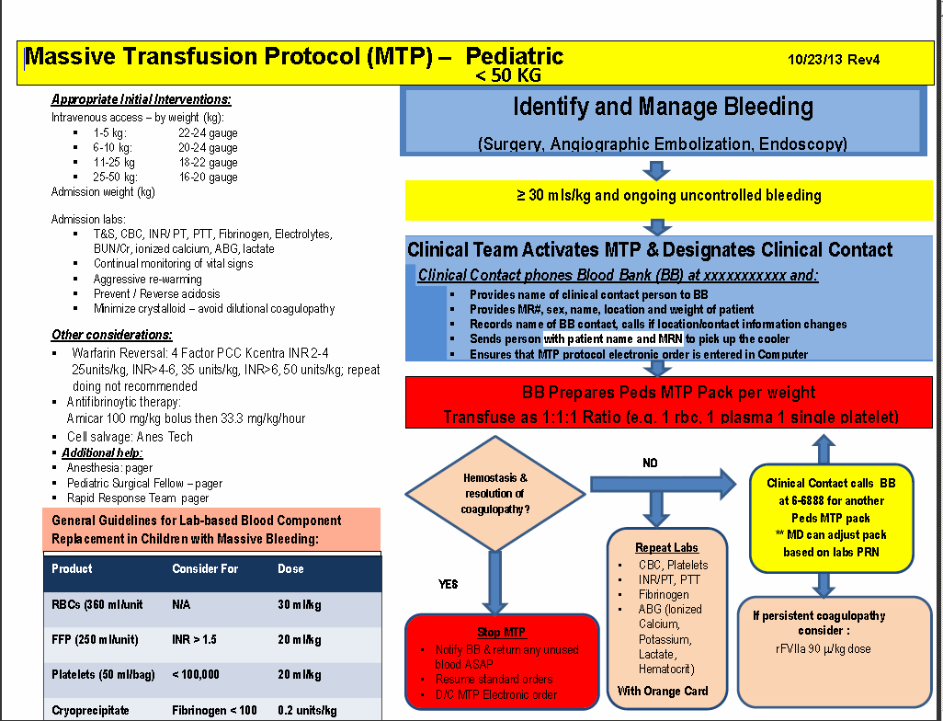

References
Adult
- Sihler KC, Napolitano LM. Massive transfusion: new insights. Chest. 2009 1. Dec;136(6):1654-67. Review.
- Sihler KC, Napolitano LM. Complications of Massive transfusion. Chest. 2010 Jan;137(1):209-20. Review.
- Borgman MA, Spinella PC, Perkins JG, Grathwohl KW, Repine T, Beekley AC, Sebesta J, Jenkins D, Wade CE, Holcomb JB. The ratio of blood products transfused affects mortality in patients receiving massive transfusions at a combat support hospital. J Trauma. 2007 Oct;63(4):805-13.
- Damage Control Resuscitation JTTS Clinical Practice Guideline, August 10, 2011 update, at http://www.usaisr.amedd.army.mil/cpgs.html
- Cotton BA, Reddy N, Hatch QM, LeFebvre E, Wade CE, Kozar RA, Gill BS, Albarado R, McNutt MK, Holcomb JB. Damage control resuscitation is associated with a reduction in resuscitation volumes and improvement in survival in 390 damage control laparotomy patients. Ann Surg. 2011 Oct;254(4):598-605.
- Holcomb JB, Wade CE, Michalek JE, Chisholm GB, Zarzabal LA, Schreiber MA, Gonzalez EA, Pomper GJ, Perkins JG, Spinella PC, Williams KL, Park MS. Increased plasma and platelet to red blood cell ratios improves outcome in 466 massively transfused civilian trauma patients. Ann Surg. 2008 Sep;248(3):447-58. Erratum in: Ann Surg. 2011 Feb;253(2):392.
- Nunez TC, Young PP, Holcomb JB, Cotton BA. Creation, implementation, and maturation of a massive transfusion protocol for the exsanguinating trauma patient. J Trauma. 2010 Jun;68(6):1498-505.

Pediatric
- Michael M. Fuenfer, ed. Border Institute, Walter Reed Army Medicine Center, Washington, DC. Chapter 5, “Transfusion Medicine” from Pediatric Surgery and Medicine for Hostile Environments.
- Dehmer JJ, Adamson WT. Massive transfusion and blood product use in the pediatric trauma patient. Seminars in Pediatric Surgery 2010;19:286-291.
- Dressler AM, Finck CM, Carroll CL, et al. Use of massive transfusion protocol with hemostatic resuscitation for severe intraoperative bleeding in a child. Journal of Pediatric Surgery 2010;324:1530-1533.
- Hendrickson J. Massive transfusion in the pediatric setting. Online document from Emory University School of Medicine 2011. Seabb.org/…/doc…/95-massive-transfusion-in-the-pediatric-setting-2011.
- Nester T and Kang M. Guidelines for pediatric transfusion at HMC. Online document for Harborview Medical Center, University of Washington 2003. www.cbbs.org/enf/attachments/ped_txprotocol_nov08.pdf

Committee Members
Name | Department
 | Chairman/Anesthesia
 | UMH CIDDS
 | Blood Bank
 | Surgery/OCA
 | Pathology
 | Vascular Surgery
 | Pathology
 | Blood Bank
 | Cardiac Anesthesia
 | Hospital Administration
 | Cardiac Surgery
 | Hem/Onc Nursing
 | Pediatric Nursing
 | Peds Hem/Onc
 | Medical ICU
 | Pathology
 | Education Nurse Coordinator
 | Intensive Care
 | OB-Gyn
 | Internal Medicine
 | Hem/Onc
 | Pathology

Please direct any questions and concerns to the Transfusion Committee

