[Social media post to the public – time-sensitive]

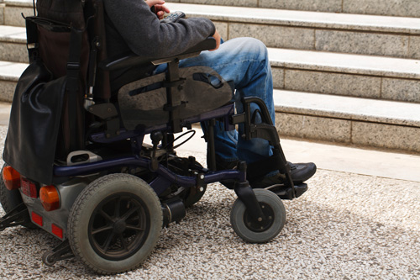
Source: CDC
Two Bills with “Heart” in the Legislature – Your help is needed

Patients devastated by car-crash injuries and their families are waiting to see whether Gov. Gretchen Whitmer and the Michigan House embrace bills to update the state’s health-care reimbursement models that have slashed payments for their care since 2021.
In 2019, Whitmer signed legislation to reduce reimbursement for hospital care for car-accident victims with catastrophic injuries as part of revisions to the state’s no-fault auto insurance law. The measures approved in 2019 have led many home-care agencies to cut back their level of service, close their doors, or decline to accept new patients. The result has been chaos – even tragedy -- for the seriously injured, and the expense of care has forced some families into bankruptcy. Even those needing at-home rehab or less intensive nursing care saw their lives disrupted.
The Michigan House went into its December recess without acting on Senate bills 530 and 531 that would reverse the 45% reduction and raise reimbursement for the care of these patients in hospitals. According to press reports, the Governor’s office and the Michigan Department of Insurance and Financial Services have opposed the legislation and called for a “narrower solution,” possibly some form of relief for home-care agencies.
Please contact your Michigan representative as well as Governor Whitmer to voice your support for SB 530 and SB 531.
For more details about how the 2019 auto no-fault revisions have affected peoples’ lives, see reporting by Chad Livengood of the Detroit News. Livengood has written about 5-year-old quadriplegic Annabelle Marsh, who was injured after the 2019 law was signed, and 64-year-old Brian Woodward, who died this past July.

