


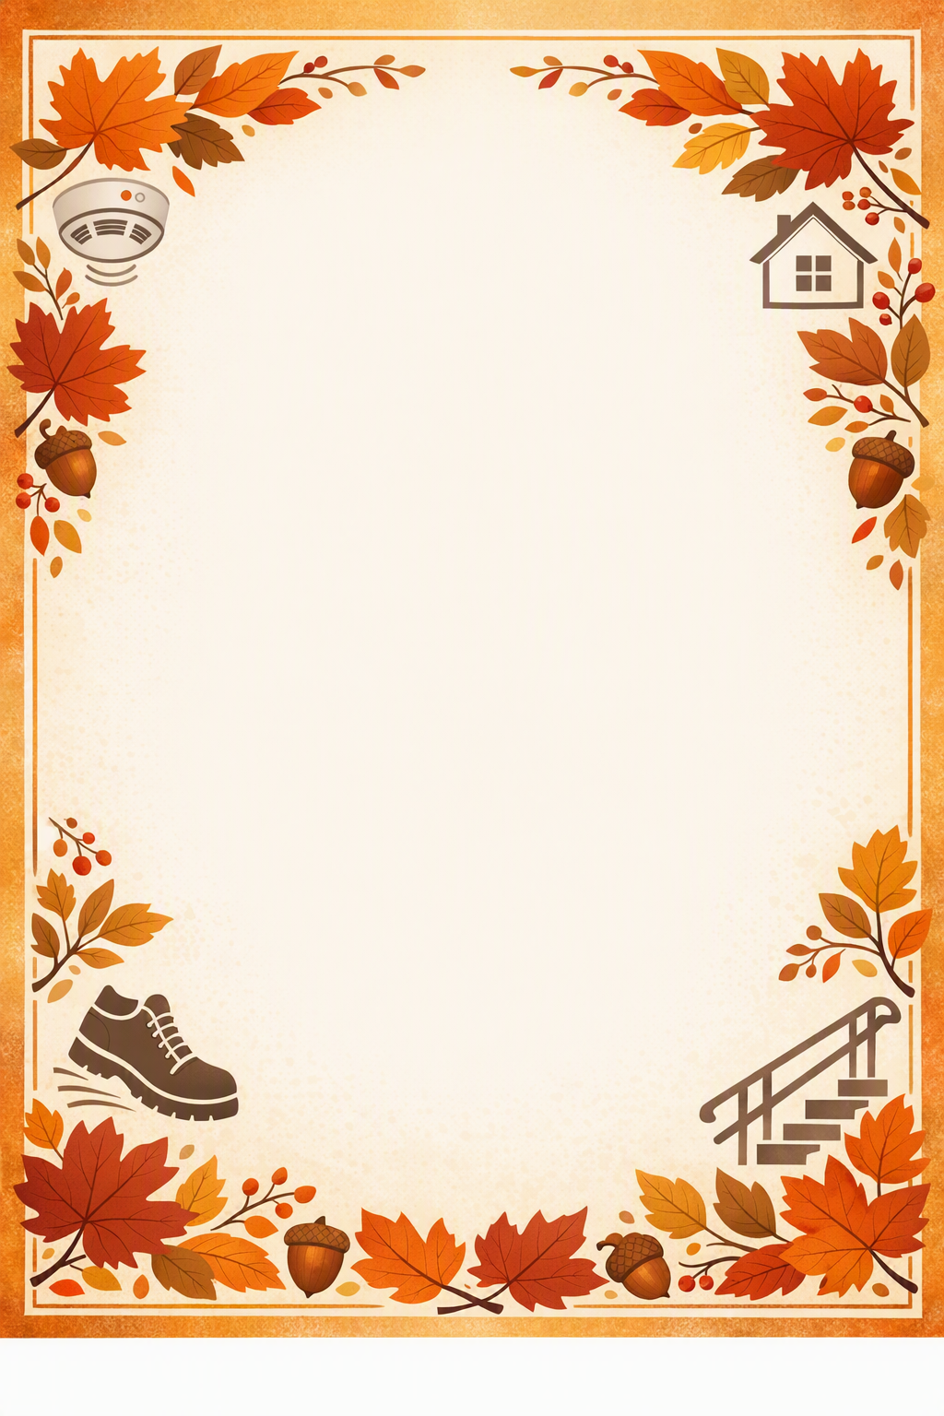
We Love Fall…Prevention!
Wednesday, October 28, 2026
1:00 p.m. - 2 p.m.
Jackson Crouch Senior Center
1715 Lansing Ave, Jackson, MI
Join Us For:
- Education, Fun, & Giveaways
- Steps to Safety Presentation
- Fall Prevention, Balance, & Mobility Tips
- Fire Safety with Jackson Fire Dept.
- And more!!

To register or for more info, please contact:
Laurie Mead: 517.768.8691
LMead@MiJackson.org

